EDRC Use Case 1, Test Case 1, Section 7.2.12 Service Continuous 7.2.13 Service Intermittent
Revision of EDRC doc:

11 | Updated to reflect comments from David Price | K Willshaw  30 March 2015

Test case spec release 1.0

Here we are describing the nature of the Activity of Pumping that the pump participates in. So the first thing we must do is declare and classify the activity as an instance of the ClassOfActivity PUMPING
Define Object (ClassificationOfIndividual)

Role  No | Role Name | Role Type | Example
1 | hasClassified | PossibleIndividual | Uuid of Activity
2 | hasClassifier | ClassOfIndividual | PUMPING

We may then classify the Activity as either Continuous or Intermittent

Role Name | Role Type | Role Value
hasActivity | PossibleIndividual | Identifier of Activity declared above
hasClassifier | ClassOfIndividual | CONTINUOUS DUTY  or  INTERMITTENT DUTY

Comment – in order to enable a query to ensure that an activity was classified by one of these two options a new RD class was created with them as members, making it in the context of a company-specific RL :
http://www.mycompany.com/iso15926/edrc/refdata#PUMP_OPERATION_DUTY_CYCLE_TYPE

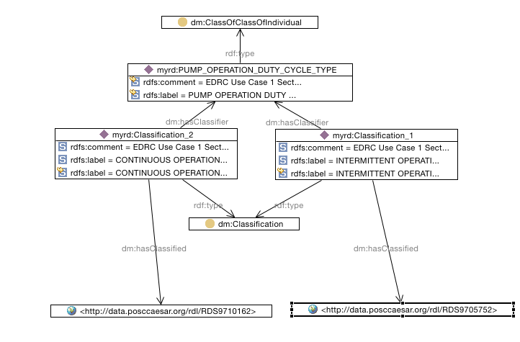

SPARQL to find all Activity instances with an Operation Duty Cycle

SELECT ?Activity ?ServiceDutyCycle
WHERE {
?Activity rdf:type dm:Activity .
?classificationofindividual tpl:hasClassified ?activity .
?classificationofindividual rdf:type tpl:ClassificationOfIndividual .
?classificationofindividual tpl:hasClassifier ?ServiceDutyCycle .
?classification dm:hasClassifier myrd:PUMP_OPERATION_DUTY_CYCLE_TYPE .
?classification dm:hasClassified ?ServiceDutyCycle .
?classification rdf:type dm:Classification .
}

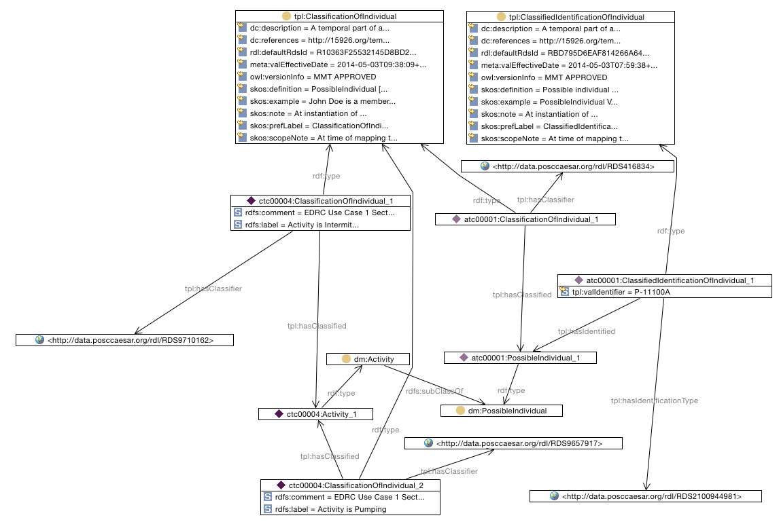

SPARQL to find Pump under CONTINUOUS_OPERATION Duty Cycle

SELECT ?PumpIdentifierRolePUMPEROfTypeCONTINUOUS_OPERATION
WHERE {
?classificationofindividual2 tpl:hasClassified ?possibleindividual .
?classificationofindividual2 tpl:hasClassifier <http://data.posccaesar.org/rdl/RDS416834> .
?classificationofindividual2 rdf:type tpl:ClassificationOfIndividual .
?classificationofindividual tpl:hasClassifier <http://data.posccaesar.org/rdl/RDS9710162> .
?classificationofindividual rdf:type tpl:ClassificationOfIndividual .
?classificationofindividual tpl:hasClassified ?activity .
?classifiedidentificationofindividual tpl:hasIdentified ?possibleindividual .
?classifiedidentificationofindividual rdf:type tpl:ClassifiedIdentificationOfIndividual .
?classifiedidentificationofindividual tpl:hasIdentificationType <http://data.posccaesar.org/rdl/RDS2100944981> .
?activity rdf:type dm:Activity .
?classificationofindividual1 tpl:hasClassified ?activity .
?classificationofindividual1 tpl:hasClassifier <http://data.posccaesar.org/rdl/RDS9657917> .
?classificationofindividual1 rdf:type tpl:ClassificationOfIndividual .
?possibleindividual rdf:type dm:PossibleIndividual .
?classificationasdutycycle a dm:Classification .
?classificationasdutycycle dm:hasClassified <http://data.posccaesar.org/rdl/RDS9710162> .
?classificationasdutycycle dm:hasClassifier myrd:PUMP_OPERATION_DUTY_CYCLE_TYPE .
?classifiedidentificationofindividual tpl:valIdentifier ?PumpIdentifierRolePUMPEROfTypeCONTINUOUS_OPERATION .
}

